Here this screenshots says about the home UI where songs are available (fetched from API) where one can see a nice hovering effect and a smooth interface here one can save the song to fav and to playlist in handy manner

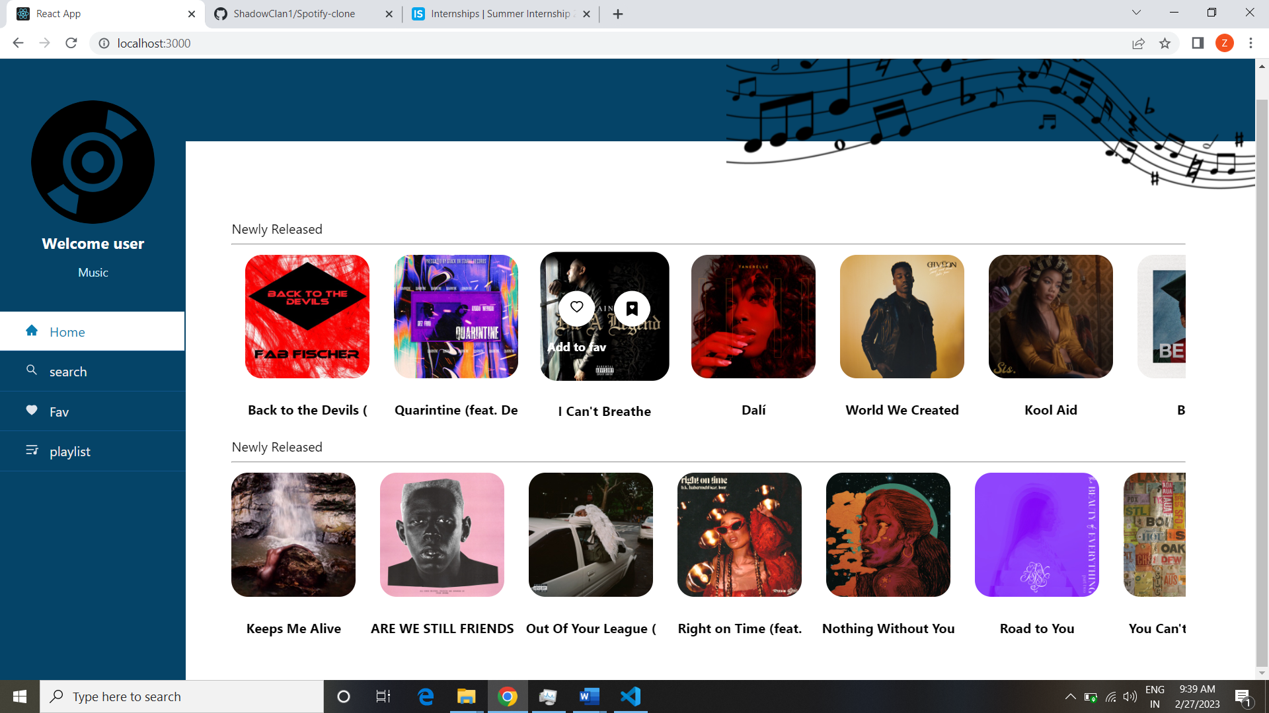

Here horizontal scroll is used so the user can see next songs as well. Now working of fav function- >

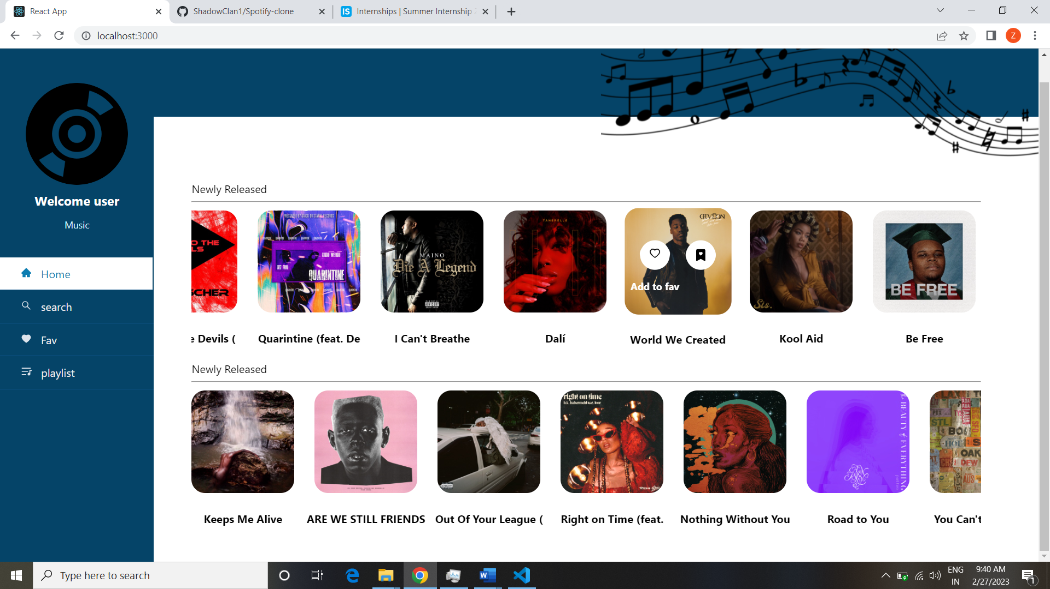

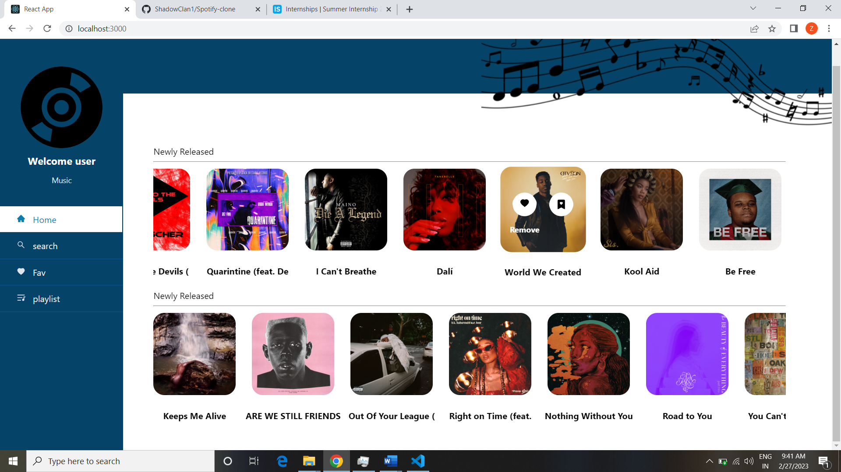

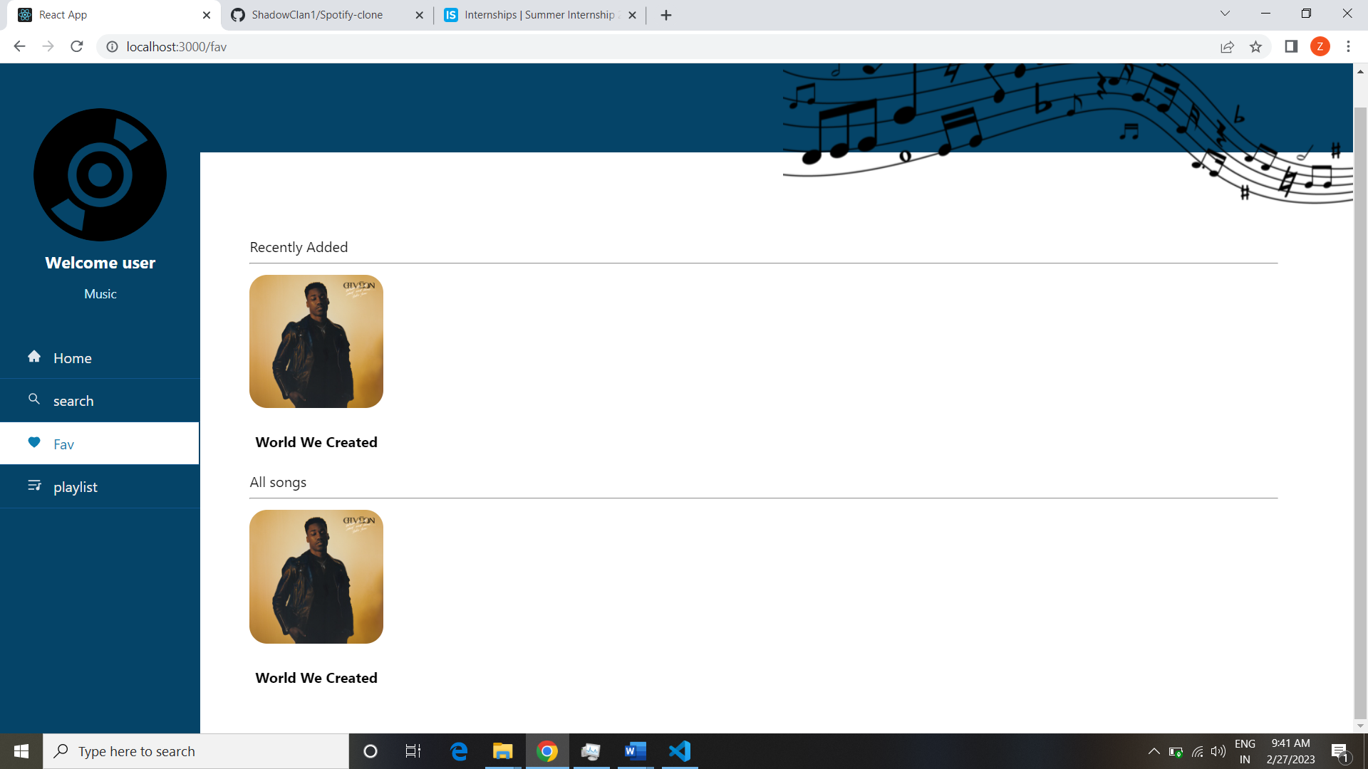

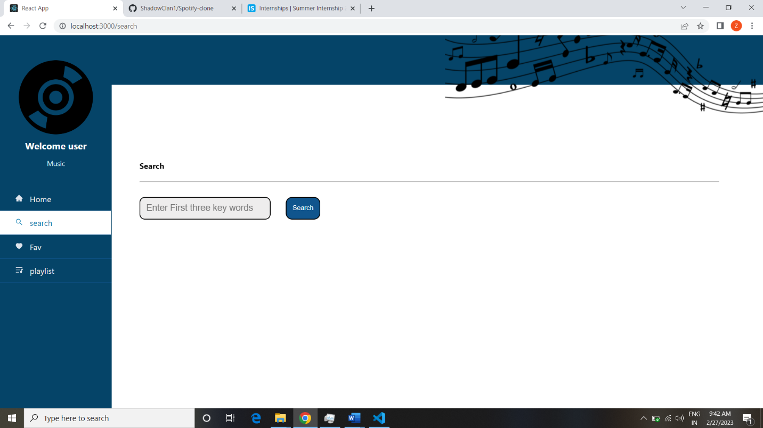working of search feature

